INFORMATION PACKET 2023-2024
Boho Dance studio
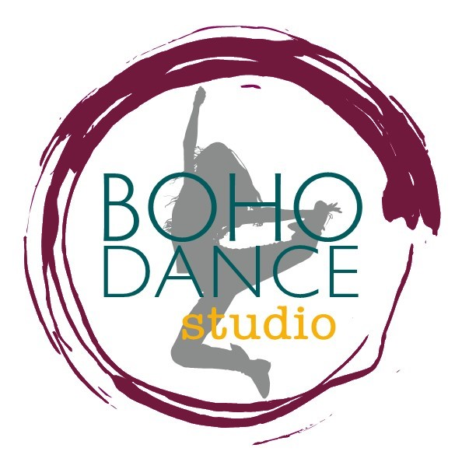

Mission Statement:
We are committed to providing exceptional dance instruction and instilling a deep appreciation for the art of dance in a safe, supportive and creative environment.

Vision Statement:
Boho Studio’s vision is to build a studio that adequately fulfills our community’s need and desire for dance and physical fitness through the fine arts. We will strive to continually encourage our dancers to enhance their knowledge and technique of the dance styles offered at the studio. We hope to inspire our dancers to acquire the proper application of self-expression, discipline, creativity, performance confidence and core values.

About the Instructors:
Adriana Ankenman, Instructor

Lindsey Peterson, Owner/Director/Instructor
Lindsey Peterson has been dancing to the beat of her own drum since she was born. During her youth she studied at The Dance Place in Colby, KS under the instruction of Colleen Barrett. Lindsey enjoyed learning many forms of dance including ballet, hip-hop, jazz/lyrical, and tap!
Lindsey danced under professional instruction consistently from age 7 to age 18 and continues to dance through life every day. Lindsey was the captain of the dance team at Colby High School for four years and then earned a full ride scholarship to join the dance team at Colby Community College in 2001.
As an adult, she began teaching at CATTS Gymnastics and Dance in Wamego, KS. In 2017, Lindsey and her family relocated to Norton, KS with a dream of starting her own studio. She enjoys her family, friends, and watching young children succeed in life with the gift of dance.
Email: bohostudio110@gmail.com
Work: 785-877-0440
Cell: 785-410-6345
Information about Boho Dance Studio:
Classes Start: September 11, 2023
Last date to join the studio (if classes are not closed): Sept 30th
Location: 110 S 1st St.
Norton, KS 67654
Contact Info: 785-877-0440
www.bohostudioks.com
Hours of Operation: Evenings (Monday-Thursday)
Regular classes run September-May
Exercise classes will be held throughout the week.
Dress Rehearsal: (Tentative) TBD (May 2024)
Recital: (Tentative) TBD (May 2024)

CLASS INFORMATION:
*Students will be enrolled in class according to age group and skill level*
Instructor: Adriana Ankenman
Preschool: 3 and 4 year olds (*MUST BE COMPLETELY POTTY TRAINED*)
Instruction – 45 min: Jazz and Creative Movement
Kindergarten: 5 and 6 year olds
Instruction – 1 hour: Jazz and Creative Movement
1st grade:
Instruction – 1 hour: Jazz, Hip Hop, Creative Movement
Instructor: Lindsey Peterson
2nd grade:
Instruction – 1 hour: Jazz, Hip Hop, Creative Movement
3rd/4th grade:
Instruction – 1 hour: Jazz, Lyrical/Creative Movement, Hip Hop
5th/6th/Junior High:
Instruction – 1 hour: Jazz, Lyrical, Hip Hop
High School:
Instruction – 1 hour: Jazz, Lyrical, Hip Hop
Instructor: Lindsey Peterson
Adult (age 18+)
Instruction – 1 hour: Jazz
Fiesta Funk
Instruction – 1 hour latin/hip hop exercise dance class

CLASS SCHEDULE
Monday:
5-6 pm – 2nd grade Lindsey Peterson
6-7 pm – 3rd & 4th grade Lindsey Peterson
7-8 pm – 5th & 6th grade & JH Lindsey Peterson
8-9 pm – HS Lindsey Peterson
Tuesday:
5:15-6 pm – Preschool (3 & 4 year olds) Adriana Ankenman
6-7 pm – Kindergarten Adriana Ankenman
7-8 pm – 1st grade Adriana Ankenman

Rules and Expectations for Boho Dance Studio:
CODE OF CONDUCT: DANCERS ARE EXPECTED TO BE AT CLASS ON TIME AND PREPARED IN RIGHT TO DISMISS ANY DANCER FROM CLASS WHOSE ATTITUDES ARE UNSATISFACTORY. HERE AT BOHO DANCE STUDIO, WE PROMOTE ALL DANCERS TO TREAT EACH OTHER WITH RESPECT, SUPPORT AND ENCOURAGEMENT.
Fees and Tuition:
Fees
- There will be no reimbursements for missed classes.
- The studio will be closed for Thanksgiving, Christmas and Spring breaks. Tuition rates will not change; fees will remain the same.
- If the local school is closed due to poor weather, there will be no dance classes that evening. If a makeup class is needed, the instructor will schedule accordingly and notify all students, otherwise, the class will be skipped.
- Costume Fees (Due in January)
*Note: We will inform parents of costume prices as soon as we have that information. Please plan on $100-150 total depending on age.
Tuition
- Enrollment Fee - $25.00 Due annually in September
- Monthly Costs:
- 45 minute (Pre-K & K only) and 1 hour instruction/week (Pre-K through Junior High)
$40/month for Sept-May
- 1 hour instruction/week (High School)
$40/month for Sept-May
Payment Policy
Customers will pay monthly. Classes will run September-May every year. Payments are due at the FIRST CLASS of each month. If Director doesn’t receive monthly payment, the customer will receive a notice. If payment isn’t received within 5 days of notice, a $10.00 late fee will be added. There is a $25 charge to all returned checks. Customers are encouraged to pay online through the website (www.bohostudioks.com)

DANCE CLASS ATTIRE: All students need to wear proper dance attire to class. At no time may a student wear jeans to class. Proper Dance Attire and Shoes are MANDATORY for safety and the overall well being of the student’s dance education. An instructor reserves the right to dismiss a student from class after one warning. Please respect our policy, it is to benefit the students and allow them to become the dancer they desire to be. We do not recommend that you share dance shoes, it is not good for sanitary reasons and does not ensure proper fit of dance shoes.
*IMPORTANT: PROPER DANCE SHOES AND ATTIRE ARE MANDATORY.
DRESS REHEARSAL AND RECITAL ARE MANDATORY.
SITTING OUT: If a student is unable to dance, but is feeling well enough to attend class, we expect them to participate by observing so that they will retain key elements of class. Students who feel ill, have a fever, or are exhibiting “contagious” cold symptoms should stay home and rest. Cases of prolonged absence due to illness or injury should be discussed with the teacher.
INSURANCE: BOHO DANCE STUDIO DOES NOT CARRY MEDICAL INSURANCE FOR ITS STUDENTS. It is required that all dance students be covered by their own family insurance policies.
SNOW OR BAD WEATHER: Boho Dance Studio generally follows the school closings. The studio will post closings on the website and Facebook page accordingly.
HOLIDAYS: Holiday dates will be posted and will be given to your child prior to holiday periods and reminders will be posted on our website/Facebook page. Other cancellations due to games/school conflicts or other out of town events will also be posted in advance and sent home with students ahead of time and posted on our website calendar.
CLASS OBSERVATION: There will be a few opportunities a year for parents to observe classes. This will be decided and communicated in advance with parents via notes going home, Facebook page and website. Otherwise, only students will be allowed in the studio during class. This rule is in place so students training and classes go uninterrupted. If parents want pictures of class please ask in advance for instructors approval, pictures are to be taken in a timely manner and persons must leave the room after the task is finished.
RECITAL: The recital will be held at the end of each regular season in May. Dates of this event will be advertised at a later date and will be posted before January 1st. It is up to parents and guardians to make sure they do not schedule any other events during this time that may interrupt the dancers’ performance dates.

**IMPORTANT STUDIO RULES**
- NO GUM CHEWING IN ANY CLASS
- HAIR MUST BE SECURED UP OFF OF NECK AND FACE IN ALL CLASSES
- NO TOYS OR JEWELRY IN DANCE CLASS
- NO ONE IS ALLOWED IN CLASS OTHER THAN DANCERS.
- STUDENTS SHOULD HAVE WATER BOTTLE HANDY FOR SMALL DRINK BREAKS, IT WILL BE NEEDED AND IS NECESSARY FOR DANCERS TO STAY HYDRATED THROUGHOUT CLASS.
- PLEASE USE RESTROOM BEFORE CLASS.
- SHOES AND PROPER DANCE ATTIRE IS REQUIRED
- DANCERS ARE TO BE PICKED UP PROMPTLY FOLLOWING CLASSES AND CAN ONLY LEAVE WITH PERMISSION FROM PARENT PRIOR TO CLASS
- IF YOU HAVE ANY OTHER QUESTIONS OR CONCERNS PLEASE DISCUSS THEM WITH DIRECTORS OR INSTRUCTORS WHEN IT DOES NOT INTERFERE WITH CLASS. WE ARE ALWAYS INTERESTED IN IMPROVING OUR DANCE EDUCATION PROGRAMS AND EVERY SUGGESTION WILL BE TAKEN INTO CONSIDERATION.
- PARENTS SHOULD CALL AT LEAST TWO HOURS AHEAD TO LET US KNOW IF A STUDENT WILL NOT BE IN CLASS.
BOHO DANCE STUDIO IS COMMITTED TO PROVIDING EXCELLENT DANCE EDUCATION IN A CLEAN, FRIENDLY, FAMILY ORIENTED ENVIRONMENT. THE POLICIES AND RULES ARE TO ENSURE THAT ALL DANCERS GET THE EDUCATION THEY DESERVE. WE HOPE YOU ENJOY THE DANCE SEASON AND LOOK FORWARD TO A FUN AND EXCITING DANCE YEAR.

We are excited to have you as a part of this new adventure! Let’s dance!

